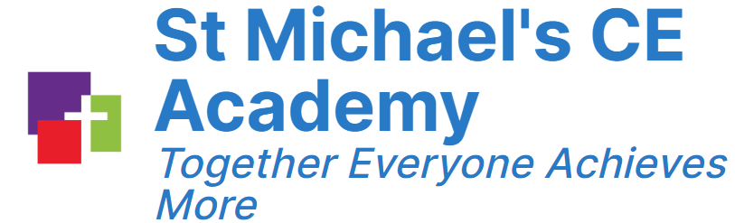
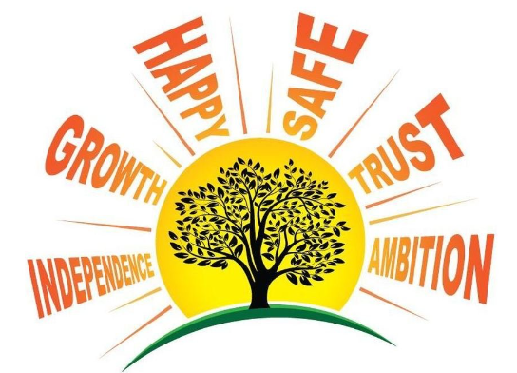

PE
Curriculum Map Document

 | Autumn 1 | Autumn 1 | Spring 1 |  | Spring 2 | Summer 1 | Summer 2
Little learners | Physical Development  •Fit themselves into spaces, like tunnels, dens, and large boxes and move around in them.  •Enjoy starting to kick ball, throw and catch balls.  •Build independently with a range of appropriate resources.  •Begin to walk independently – choosing appropriate props to support at first.  •Walk, run, jump and climb – and start to use the stairs independently.  •Spin, roll and independently use ropes and swings.  •Sit on a push a long-wheeled toy, use a scooter or ride a tricycle.  Expressive Arts and Design  •Respond emotionally and physically to music when it changes.  •Move and dance to music.  Personal, Social and Emotional Development  •Select and use activities and resources, with help when needed. This helps them to achieve a goal they have chosen or one which is suggested to them.  •Increasingly follow rules, understanding why they are important.  •Remember rules without needing an adult to remind them.  Physical Development  •Continue to develop their movement, balancing, riding (scooters, trikes and bikes) and ball skills.  •Go up steps and stairs, or climb up apparatus, using alternate feet.  •Skip, hop, stand on one leg and hold a pose for a game like musical statues.  •Use large-muscle movements to wave flags and streamers,  paint and make marks.  •Start taking part in some group activities which they make up for themselves, or in teams.  •Increasingly able to use and remember sequences and patterns of music that are related to music and rhythm.  •Match their developing physical skills to tasks and activities in the setting. For example, they decide whether to crawl, walk or run across a plank, depending on its length and width.  •Choose the right resources to carry out their own plan. For example, choosing a spade to enlarge a small hole they dug with a trowel.  •Collaborate with others to manage large items, such as moving a long plank safely, carrying large hollow blocks.  •Show a preference for a dominant hand.  •Be increasingly independent as they get dressed and undressed. For example, putting coats on and doing up zips.  Expressive Arts and Design  •Respond to what they have heard, expressing their thoughts and feelings.
Nursery | Personal, Social and Emotional Development  •Manage their own needs.  -personal hygiene  •Know and talk about the different factors that support overall health and wellbeing:  -regular physical activity  Physical Development  - Revise and refine the fundamental movement skills they have  already acquired:  - rolling - running  - crawling - hopping  - walking - skipping  - jumping - climbing  - Progress towards a more fluent style of moving, with  developing control and grace.  - Develop overall body-strength, balance, coordination and agility needed to engage successfully with future physical education sessions and other physical disciplines, including dance, gymnastics, sport and swimming.  - Use their core muscle strength to achieve a good posture  when sitting at a table or sitting on the floor.  - Combine different movements with ease and fluency.  - Confidently and safely use a range of large and small  apparatus indoors and outdoors, alone and in a group.  Develop overall body strength, balance, coordination and agility.  Expressive Arts and Design  • Explore, use and refine a variety of artistic effects to express  their ideas and feelings.  • Return to and build on their previous learning, refining ideas  and developing their ability to represent them.  • Create collaboratively, sharing ideas, resources and skills.  • Listen attentively, move to and talk about music, expressing their feelings and responses.  • Watch and talk about dance and performance art, expressing their feelings and responses.  • Explore and engage in music making and dance, performing solo or in groups.
Reception | Links to the following ELGs:  Physical Development:  Gross Motor Skills ELG  Children at the expected level of development will:  • Negotiate space and obstacles safely, with consideration for themselves and others;  • Demonstrate strength, balance and coordination when playing; Move energetically, such as running, jumping, dancing, hopping, skipping and climbing.  Personal, Social and Emotional Development  Managing Self ELG  Children at the expected level of development will:  • Be confident to try new activities and show independence, resilience and perseverance in the face of challenge;  • Explain the reasons for rules, know right from wrong and try to behave accordingly;  • Manage their own basic hygiene and personal needs, including dressing, going to the toilet and understanding the importance of healthy food choices
Reception |  |  |  | Body management | Cooperative and solve problems | Speed, Agility and Travel | Manipulatives and coordination
Year 1 | Attack, defend and shoot | Gymnastics | Send and return |  | OAA | Hit, catch and run | Run, jump and throw
Year 2 | Attack, defend and shoot | Gymnastics | Send and return |  | OAA | Hit, catch and run | Run, jump and throw
Year 3 | Football | Volleyball | Gymnastics |  | OAA | Rounders | Athletics
Year 4 | Basketball | Tennis | Gymnastics |  | OAA | Rounders | Athletics
Year 5 | Swimming | Swimming | Swimming |  | Swimming | Swimming | Swimming
Year 6 | Rugby | Badminton | Gymnastics |  | OAA | Rounders | Athletics

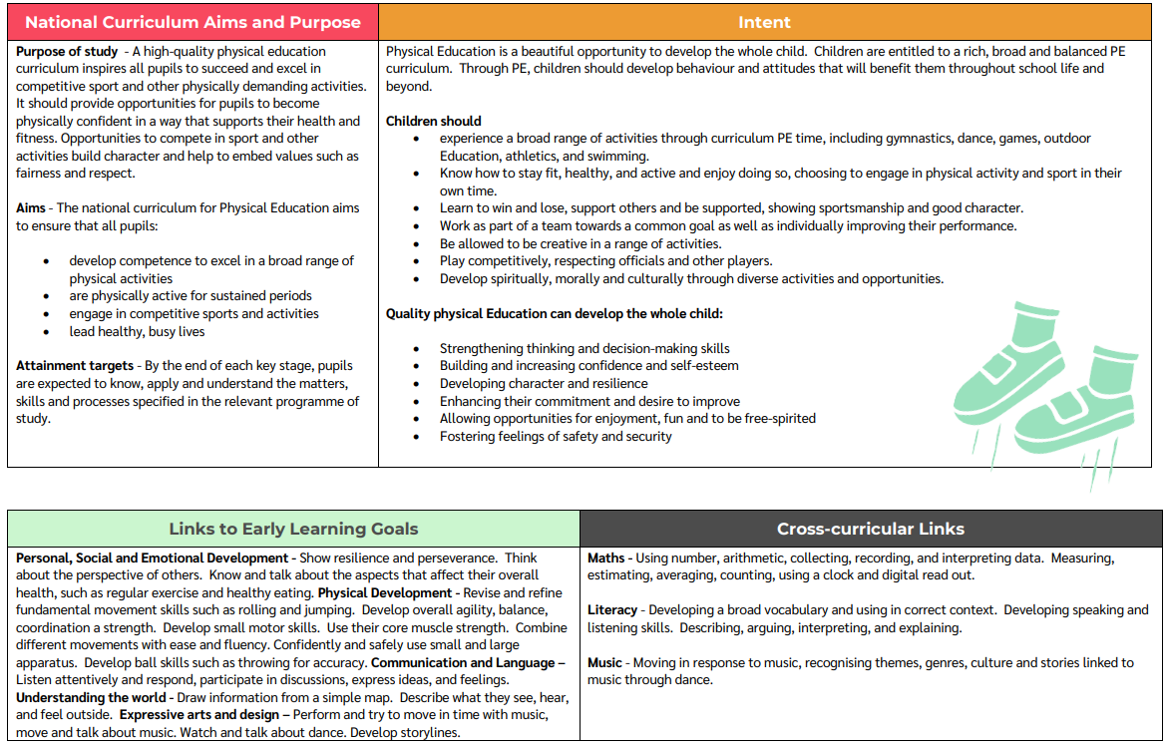
Skills and Knowledge Progression

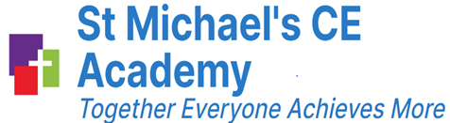
St Michael’s CE Academy

Our Vision
St. Michael’s is like a tree: where through God’s light and deeply rooted Christian values, we grow and prosper. We shine with ambition in a happy, caring and safe Christian family.

At St Michael’s CE Academy, we aim to provide all of our pupils with a high-quality education within a caring Christian environment where Christian values of trust, forgiveness, friendship, truthfulness and perseverance, hope, responsibility, thankfulness, justice and peace are embedded. Pupils develop a growing understanding of these Christian values as they progress through the school and this is reflected in, and impacts on, their behaviour and attitudes to each other, the whole school, the wider community and their daily life.

Our Intent
At St Michael’s, we recognise the importance of being active and the impact it has on a child’s physical, emotional, social and mental health. As a school, we want to promote participation in sport and living an active, healthy lifestyle to encourage lifelong participation once they leave us.
Our principles
At St Michael’s we:
1.Trust
During a pe lesson, children are continuously given opportunities to demonstrate trust. Firstly, children need to have trust in their own abilities to have a go at new skills, take chances and trust their instincts. Secondly, they will begin to trust others within team settings. Children will be given opportunities to feel they are in a position of trust by setting up for games or being a leader.
2.Growth
Through good role models in PE, children can grow their personal attributes such as: communication, fairness, team work and ability to be mature in competition. This is vital substantive knowledge that children can use throughout their education and building on these skills year on year will create resilient children.

3. Ensure that we are ambitious
Physical education should inspire children to adapt a competitive attitude to succeed in skills and games. A rich, broad and balanced curriculum will promote intrinsic motivation to improve themselves and create a positive attitude towards going above and beyond to succeed.
4.Happy
The children will grow up to live happy and healthy lives; utilising the skills and knowledge developed through PE. As a school, we aim to encourage lifelong participation once they leave us.
5.Safety
Our children will develop a range of fundamental movement skills and game tactics. Classes will work together in teams and individually in an environment where they feel secure to make mistakes and learn from them.
6.Independence
Children will take time to evaluate their own practice to progress lesson by lesson. Frequently, children will be expected to independently practice skills after a demonstration. Allowing children to collect equipment, set up games and tidy up all foster’s independence.
As a consequence of adopting these principles, St Michael’s children will:
- Participate in a rich curriculum such as: volleyball, tennis, badminton, football, rugby and many more
- Learn to win and lose, support others and be supported, showing sportsmanship and good character
- Know the benefits to exercise (staying fit and healthy supports not only physical health, mental, social and emotional health) which will support them in choosing to continue to live a healthy lifestyle
- Develop spiritually, morally and culturally through diverse activities and opportunities
- Play competitively, respecting officials and other players
Curriculum Rationale
The St Michael’s PE Curriculum is designed to inspire children to be active and lead happy, healthy lives while developing a passion for sport.
● In Early Years there is a firm focus on physical development which is apparent in all that they do.
● Year 1 and 2 the curriculum is centred around developing basic skills ready to start implementation into team games and activities.
● In KS2, there are many opportunities to play a variation of different sports, challenges and competitions.
● Through the wide range of sports that St Michael’s has to offer, children get to develop their skills that they have gained in KS1 and challenge themselves to improve their skills and knowledge further.
● Physical activities and sports will be encouraged and developed through lunchtime and after school clubs, external coaches and cross-curricular links in the curriculum.
PE hub justification
At St Michael’s, we use the PE Hub to teach our physical education lessons because it is a scheme offering a clear structure and skills progression throughout the year group and the whole school. The online website is used by teachers to access lesson planning for a broad range of sports and activities. Additionally, videos are found on the website that can be modelled to children to explain how to complete an activity as well as teacher demonstration; lesson break
ideas; weekly challenges for children to complete; assessment tools for teachers to use; and a curriculum builder.
Furthermore, it offers:
● a wide range of sports to be taught and learnt
● a clear learning objective for each lesson which the children will be able to follow and progress throughout the six weeks of planning.
● an evident skills progression from EYFS to Year 6.
● lots of ideas and activities that can be used outside PE lessons.
● Home booklets and challenges that children can participate in.
Children thrive in the subject because…
- There is a range of engaging activities and sports
- In each area there are always ways to challenge and test themselves
- Children will work together in teams and individually in an environment where they feel secure to make mistakes and learn from them on a weekly basis.

