

SEND Information Report
2023-2024

Reviewed: 14.9.23 by Faz Islam (Headteacher) and Helen Boutle (SENDCO)
Contents:
Please use this contents guide to help to lead you through this document
Our school context
What is a Special Educational Need and Disability?
Types of SEN provided for at St Michael’s CE Academy
How we identify pupils with SEND and assess their needs
What do I do if I think my child has Special Educational Needs (SEND)?
Important contact details
Admission arrangements for disabled pupils
How we consult with pupils and their parents/carers and involve them in the education of their pupils.
How St Michael’s CE Academy assesses and reviews pupil progress towards outcomes.

How your child can be supported during transition into and between schools.

St Michael’s CE Academy’s approach to teaching pupils with SEND, and the additional support that is available to them.

The Graduated approach to supporting SEN pupils.
How we evaluate the effectiveness of our provision for pupils with SEN.

How we adapt the curriculum and learning environment for pupils with SEND.
Facilities we provide to help pupils with a disability access the school.

How we take steps to prevent pupils with a disability from being treated less favourably than other pupils:

Training and expertise staff have, to support pupils with SEN, and external professional expertise:
How we involve other bodies to meet the needs of pupils with SEN and to support their family (including contact details)

Support we offer pupils with SEN for their emotional, mental and social development, including extra pastoral support arrangements for listening to the views of pupils with SEN.
How parents/carers can complain about the school’s SEN provision and how complaints will be handled

What arrangements are in place to support children who are looked after by the local authority and have SEND?
How the broad and balanced curriculum provided is adapted and made accessible for pupils with SEN:

Glossary of terms

This document should be read alongside the SEND policy, the Accessibility policy, the Equality at our Academy page, the Accessibility plan and Accessibility policy which can be found on the St Michaels’ CE Academy website.
https://www.stmichaelsceacademy.org.uk

Our school context:
- St Michael’s CE Academy is a larger average two form entry primary school with a maximum number on roll of 535 pupils including 2-year-old provision, Nursery and Reception.
- The current gender balance is Boys 51.5% and Girls 48.5%
- St Michael’s Ce Academy operates in an area characterised by economic challenges, limited access to resources, and social inequalities. A considerable percentage of families face financial hardships, affecting the overall wellbeing of our pupils. The proportion of pupils known to be eligible for the pupil premium grant is above national average of 25.9% at 40.8% We recognise that these pupils require additional support to ensure they can access educational opportunities and achieve their full potential.
- St Michael’s CE Academy embraces diversity, with a substantial number of pupils coming from various linguistic backgrounds. The number of pupils whose language is not English is 26.9% which is above the national average of 22% .
- St Michael’s CE Academy is committed to inclusivity, and this is evident in the support provided to pupils with special educational needs, ensuring equal access to learning. The proportion of pupils who have SEND support is 19%. This above the national average of 13.5 . The percentage of children on an EHCP plan is 2.5%. Individual education plans and specialised provision is implemented to address the diverse needs of SEN pupils.

What is a Special Educational Need and Disability?
‘A pupil has SEN where their learning difficulty or disability calls for special educational provision, namely provision different from or additional to that normally available to pupils of the same age. Making higher quality teaching normally available to the whole class is likely to mean that fewer pupils will require such support. Such improvements in whole-class provision tend to be more cost effective and sustainable.’ (Special educational needs and disability code of practice: 0 to 25 years)
The Children and Families Act 2014 clause 20 says that:
1. A child or young person has special educational needs if he or she has a learning difficulty or disability which calls for special educational provision to be made for him or her.
2. A child of compulsory school age or a young person has a learning difficulty or disability if he or she-
(a) Has a significantly greater difficulty in learning than the majority of others of the same age, or
(b) Has a disability which prevents or hinders him or her from making use of facilities of a kind generally provided for others of the same age in mainstream schools or mainstream post 16 institutions.
3. A child under compulsory school age has a learning difficulty or disability if he or she is likely to be within subsection2. When of a compulsory school age (or would be likely, if no special education provision were made).
4. A child or young person does not have a learning difficulty or disability solely because of the language (or form of language) which is or has been spoken at home.
Types of SEN provided for at St Michael’s CE Academy:
The illustration below demonstrates the types of SEN that may be in our school:

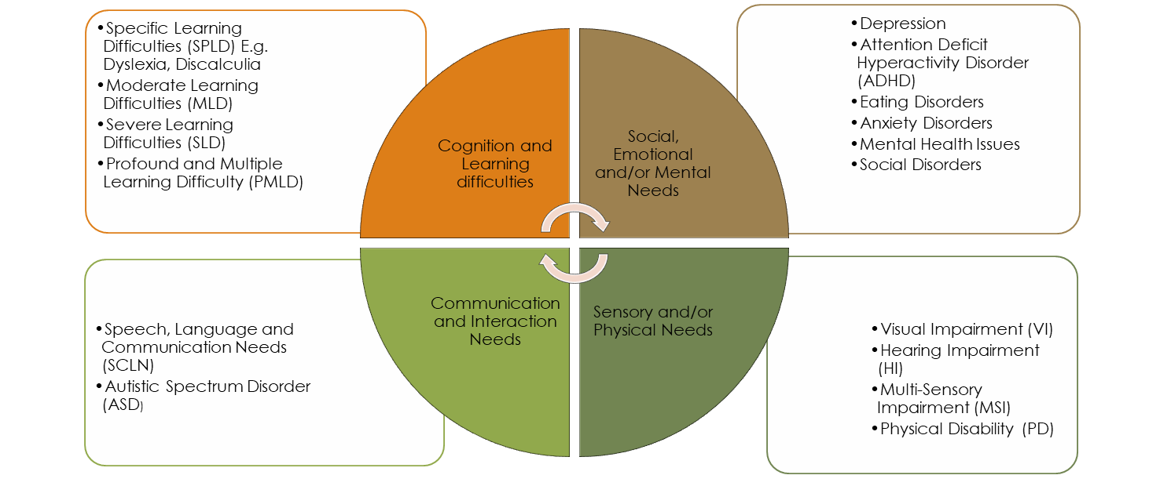

How we identify pupils with SEND and assess their needs:

The identification of SEND is built into our overall approach to monitoring the progress and attainment of all pupils. This allows us to identify pupils who are making less than expected progress at an early stage. Inadequate progress might be that which:

- Is significantly slower than that of their peers.
- Fails to match or better the child’s previous rate of progress.
- Fails to close the attainment gap between the child and their peers.
- Widens the attainment gap.

Early identification is made through:
- Pupil progress meetings where children are discussed, and needs identified.
- Discussions with parents
- Staff observations
- All forms of assessment including but not exclusively, Read Write Inc assessments, reading assessments, teacher assessments, summative assessments, monitoring and professional reports.
What do I do if I think my child has Special Educational Needs (SEND)?
Who to contact:  Helen Boutle  01924 207340 | If you have concerns about your child’s progress you could speak to their class teacher.  You can speak to the school’s SENDCO.  The Headteacher can be contacted if you have concerns about how your child’s SEND is being managed.
School response: | Where there are concerns about your child’s progress or learning, the teacher may raise this with the SENDCO.  The school has termly pupil progress meetings to monitor the progress of all pupils.  If there are further concerns about your child’s learning, the school will discuss this with you:  • Any concerns you may have.  • To plan any additional support your child may receive  • To discuss with you any referrals to outside professionals to support your child’s learning.  • How we could work together, to support your child at home/school.

Admission arrangements for disabled pupils:
If a parent would like their child to attend St Michael’s CE Academy, the normal procedures as outlined in our admissions policy should be followed. Parents can request a visit to the school with the Special Educational Needs Co-ordinator.
If the child has an Educational Health Care Plan (EHCP) or if a school is being consulted regarding an EHCP placement, processes and arrangements should be co-ordinated through SENART (Special Education Needs Assessment and Review Team). senart@wakefield.gov.uk

How we consult with pupils and their parents/carers, and involve them in the education of their pupil:
Initially, the class teacher will be able to discuss your child’s needs. The SENDCO will support the parent/carer with any enquiries or processes that are needed to help meet the needs of the child. This could involve putting together a plan, contacting agencies and completing referrals. A list of actions will be agreed.
Parents/carers will be kept informed of any developments or of external agencies visiting and any outcomes from these visits.
Meetings with the parents will be held throughout the year to inform them of progress made. Some of these meetings will be formal e.g. to hold an EHCP annual review or My Support Plan review. However, parents/carers are always welcome to make an appointment to speak to the class teacher or SENDCO.
How St Michael’s CE Academy assesses and reviews pupil progress towards outcomes:
We will follow the graduated approach and the four-part cycle of assess, plan, do, review.
The class or subject teacher will work with the SENCO to carry out a clear analysis of the pupil’s needs. This will draw on:
- The teacher’s assessment and experience of the pupil
- Assessment data including summative assessment.
- Use of Wakefield Progression Steps to track small steps of progress.
- Formative assessment
- The individual’s development in comparison to their peers and national data
- Discussions at pupil progress meetings
- The views and experience of parents
- The pupil’s own views
- Advice from external support services, if relevant
The assessment will be reviewed regularly.
All teachers and support staff who work with the pupil will be made aware of their needs, the outcomes sought, the support provided, and any teaching strategies or approaches that are required. We will regularly review the effectiveness of the support and interventions and their impact on the pupil’s progress with the support and views of parents, carers and professionals. Parents and carers are invited to review meetings in addition to parent meetings with the class teacher. The SENDCO is present in parent meetings where possible.

The Assess Plan Do Review model.

How can your child be supported during transition in school?
Transition includes moving between schools but also between year groups and Key Stage phases.
- Any child who moves to a different school or from St Michael’s CE Academy will have a transition arrangement. The SENDCOs from the two settings will discuss the child’s needs and what the child currently has in place. Files with information and reports will be handed over securely and confidentially between the school.
- Children on an Education and Health Care Plan will have a meeting early in the Autumn Term in Year 6 to decide on the secondary placement. This request will then be sent to SENART to request the transfer.
- Any parent of a child with an Education and Health Care Plan wanting a change of setting in any year will have to request a consultation by the Statutory Panel (SENART).
- Teachers will be given the opportunity to discuss class transition. This will include discussing any children identified on the SEN register. This is to ensure there is a smooth transition for the child and that the reasonable adjustments are continued.
- The SENDCO will endeavour to meet with the new and current teacher and the parents/carers of children in the Summer Term to discuss future arrangements.
- If a parent, carer, child or teacher feels that the pupil would benefit from extra transition arrangement to support them, the SENCO will liaise with the secondary placement and organise this.
- Independence and preparation towards adulthood is the aim of any plans and transitions. For example, St Michael’s CE Academy aims to prepare children to be as independent as possible in their academic and life skills. Considerations are made during review meetings regarding the next transition steps and how school can support the children in preparing for this milestone. An example would be introducing children to timetabling.

St Michael’s CE Academy’s approach to teaching pupils with SEND, and the additional support that is available to them:
The provision for our children with SEND is closely monitored and evaluated. Termly meetings between teaching staff, parents/carers and the SENCo ensure SEN Support plans are reviewed and the progress made by children is evaluated. Where interventions have not been successful, further support or alternative approaches are put in place. This may also include seeking further advice and recommendations from professionals for staff to build into future support plans.
Teaching and Learning is monitored through lesson observations, learning walks and book scrutinies. In addition to this, our SENCo monitors the effectiveness of interventions through collecting evaluations and assessments completed by staff working directly with the child. The deployment of staff is monitored and reviewed regularly to ensure skills and areas of expertise are matched to areas of need.
Ongoing assessment of pupils with SEND is monitored by the Senior Leadership Team at termly Pupil Progress Review Meetings. The progress of children with SEN is considered in the context of the whole school and assessed against national averages. Where necessary, further interventions will be put into place for children who are not deemed to be making adequate progress.
The Graduated approach to supporting SEN pupils.
At St Michael’s CE Academy, we offer a graduated approach to Special Educational Needs and Disabilities so that a child will initially be supported by high quality teaching.
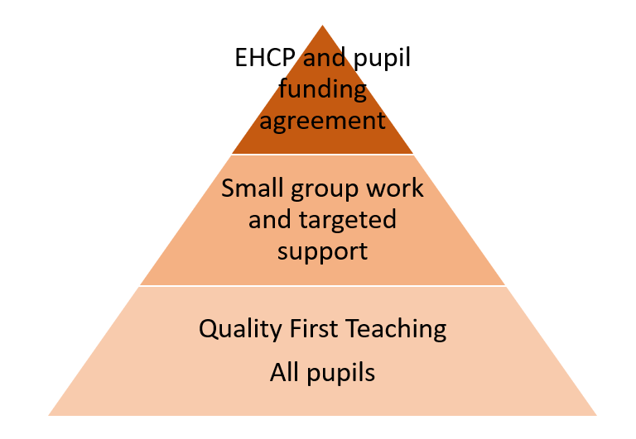

Types of support | What would this mean for your child? | Who receives this support?
Class teacher- high-quality first-class teaching  First wave of intervention | - Ensuring that the class teacher has the highest possible expectations for your child and all pupils in their class.  - Ensuring that all teaching is based on building on what your child already knows, can do and can understand.  - Differentiated tasks, using different ways of teaching so that your child is fully involved in learning in class. This may involve more practical learning or providing different resources adapted to your child. This may include using concrete resources e.g. cubes, counters, word mats etc.  - Putting in place specific strategies (which may be suggested by the SENDCO or outside agencies) to support your child’s learning.  - Your child’s progress is continually monitored by the class teacher.  - Attendance, engagement in learning and behaviour are also monitored.  - You will be informed of your child’s progress and attainments at parent evenings and in the end of year school report. | All children in school
Interventions: Specific small group / individual work | Sometimes, a specific intervention may be needed to help close the gap between your child’s achievement and that of their peers.  This may be implemented by the teaching assistant or be an independent task that will develop skills. Examples include, spelling interventions, number interventions including number bonds or help with times tables.  These interventions will be monitored by the class teacher to see if they are effective or not and be adapted as necessary. | Any child who had gaps in his or her learning or understanding
Early intervention/ One Page Profile/  Pupil passport | This is where your child’s name has been placed on the Special Educational Needs Register.  Your child will have a One Page Profile which will have short term targets that are currently being worked on.  They may have a Pupil Passport which shares information with all staff if they have any barriers to learning e.g. needs glasses.  Progress will be monitored by the teacher, with the SENDCO’s support to identify if further support is needed.  Advise may be sought from external SEND support agencies in order to put the best possible support in place. | Children who have been identified by the class teacher and the SENDCO as needing additional support
SEN support /My Support Plan | A My Support Plan should identify how the delegated budget and access to services through the Local Offer can be made to support the child/young person, as well as how a range of professionals are offering support.  MSP is a framework to record:  What is important to the child/young person and their family and how best to support them  Contributions from all advice givers  A shared understanding of an individual's strengths and needs  What is in place and what needs to change?  Agreed outcomes and actions. | Children who have been identified by the class teacher and the SENDCO as needing additional support from school and external services.
Education and Health Care Plan | An EHCP is a statutory assessment for children and young people aged 0-25 who have Special Educational Needs or Disabilities. It involves a multi-agency assessment of your child’s needs which may result in an EHCP being put in place.  The school or parents/carers can request that the Local Authority carry out a Statutory assessment of your child’s needs. This is a legal process and more information can be found on the Wakefield Council Website in the Local Offer Education Health and Care Plan (mylocaloffer.org)  After the school have sent in a request to the Local Authority, it will be decided if the child’s needs require a statutory assessment. All professionals involved with your child will be asked to contribute a report. This could include Speech and Language therapists, Educational Psychologist, Social and emotional specialist. A panel of SEN specialists will then decide if additional funding is required to meet the needs of your child.  If a plan is agreed by the Special Educational Needs Assessment and Review Team (SENART), the plan will set out agreed targets and the provision needed to meet those targets.  The EHCP will be reviewed annually by the school and the parent/carers to assess progress and to make any amendments.  The child’s voice is paramount in this process, and their views will be sought in a way that is made accessible to them.  Funding may be used for additional support from an adult to access interventions or programmes necessary to support your child e.g. Speech and language programmes. Support could be used to meet health, personal needs or physical needs. | Children with complex needs
The diagram below explains the EHCP process:
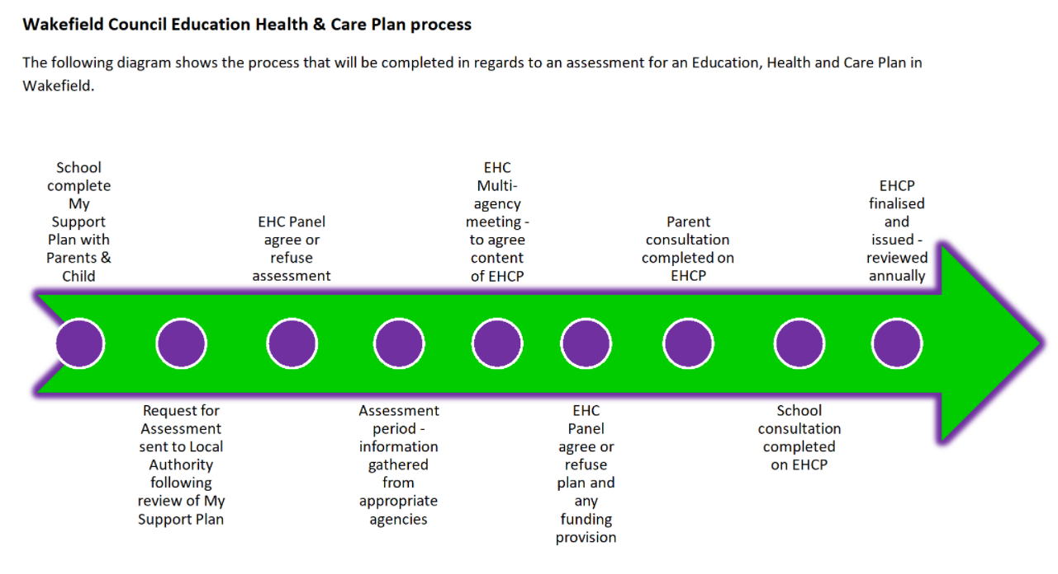

How do we evaluate the effectiveness of our provision for pupils with SEN
The provision for our children with SEND is closely monitored and evaluated. Termly meetings between teaching staff, parents/carers and the SENCo ensure SEN Support plans are reviewed and the progress made by children is evaluated. Where interventions have not been successful, further support or alternative approaches are put in place. This may also include seeking further advice and recommendations from professionals for staff to build into future support plans.
Teaching and Learning is monitored through lesson observations, learning walks and book scrutinies. In addition to this, our SENCo monitors the effectiveness of interventions through collecting evaluations and assessments completed by staff working directly with the child. The deployment of staff is monitored and reviewed regularly to ensure skills and areas of expertise are matched to areas of need.
Ongoing assessment of pupils with SEND is monitored by the Senior Leadership Team at termly Pupil Progress Review Meetings. The progress of children with SEN is considered in the context of the whole school and assessed against national averages. Where necessary, further interventions will be put into place for children who are not deemed to be making adequate progress.

How we adapt the curriculum and learning environment for pupils with SEND:
The SEND Code of Practice 2014, Paragraph 6.9, states that:
‘All schools have duties under the Equality Act 2010 towards individual disabled children and young people. They must make reasonable adjustments, including the provision of auxiliary aids and services for disabled children, to prevent them being put at a substantial disadvantage. These duties are anticipatory – they require thought to be given in advance to what disabled children and young people might require and what adjustments might need to be made to prevent that disadvantage.’
- School is required to make reasonable adjustments in order to enable your child to make progress and to access the curriculum. Examples in St Michael’s CE Academy may include, amongst others, use of pencil grips, balance cushions, ear defenders, workstations and adjusted entry and exit points.
- Environmental adjustments may be necessary following the advice of external agencies including workstations, adapted chairs, disabled changing areas, accessibility toilets and ramps. Please see the accessibility policy in regard to this.
- Curriculum adjustments may include differentiated work, concrete resources, which may include counters, cubes etc, access to prompts and word mats e.g. spellings, phonics, visual times tables. IT equipment may be used to support learning e.g. iPad or typing aids.
- ‘Task boards’ or ‘First and Then’ boards are used in most classrooms to support independent learning. Task boards allow children to follow a routine and gives them independence at their level. The task boards will be used to learn small step targets and practice skills including times tables, number bonds, spellings and handwriting.
- In some cases, additional adult support may be needed to support a child. The SEN support is managed by the class teacher under the direction of the SENDCO and the headteacher. The class teacher must be responsible for the teaching and learning of the child in their class and the SEN support is accountable to them in the first instance. Progress is monitored by the class teacher.
- Interventions are sometimes necessary to help close the gaps in your child’s learning. These should be short term interventions based on a target. Targets should be changed once a child has grasped and embedded the skill or knowledge. At St Michael’s CE Academy, interventions could, but not exclusively, include reading, writing and number. Some of these interventions have been recommended by external professionals e.g. Speech and language programmes, Rainbow words, Precision teaching, Alphabet Arc and a ‘Learning for Living programme’.
- Children sometimes need emotional and wellbeing support.
St Michael’s CE Academy has a wealth of pastoral care available to support your child. The school has two full time pastoral mentors. The school has an extensive PSHCE programme across the school.
- St Michael’s CE Academy has its own SEN provision room. The school recognise that some children need resources that are not available in the classrooms to help them make progress. The environment provides opportunities to meet sensory needs through a well resources multi-sensory room and quiet reading room. The room has an area to support meeting physical and occupational therapy needs. Speech and language targets can be met through using play and experiences e.g. finding letters in the sand, using language rich experiences such as ‘pouring’ and ‘full’ and ‘empty’ in the sand and water. There is a wealth of learning opportunities using the early years model including sand, water, small world and mark making. The areas should be used in conjunction with the classroom and the class teacher is still responsible for the progress made through this provision.
- The school now has a sensory garden through a high needs capital grant which is available to all pupils.

Our sensory garden:
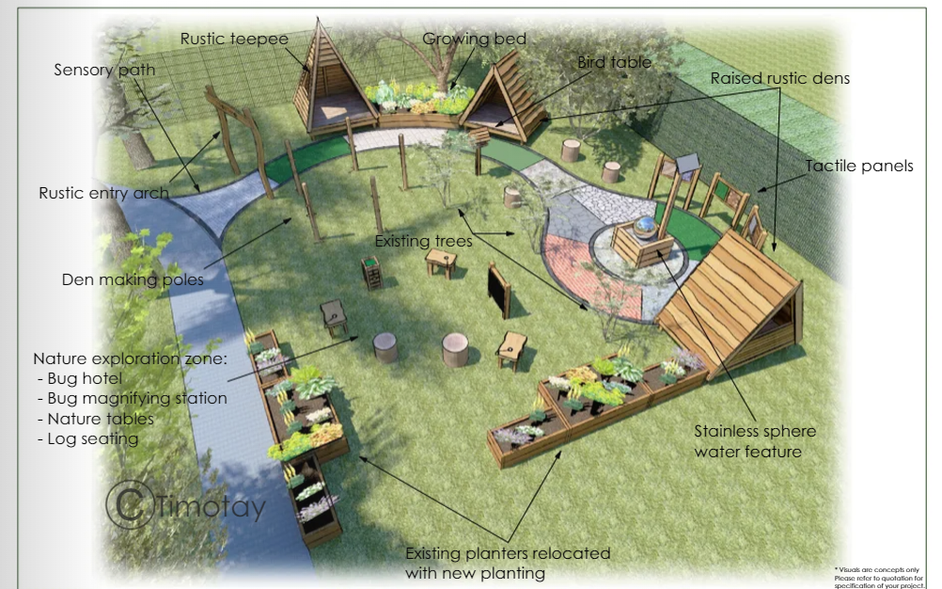

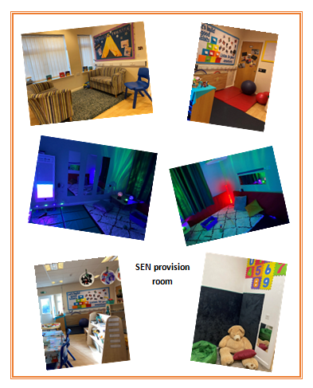

Facilities we provide to help pupils with a disability access the school.
See our accessibility policy. The school has, but not exclusively, ramps, lifts, disabled toilet and changing facilities.
How we take steps to prevent pupils with a disability from being treated less favourably than other pupils and how we enable SEN pupils to engage in activities:
All pupils access the full National Curriculum. Reasonable adjustments are made to ensure pupils can have equal access.
All of our extra-curricular activities and school visits are available to all our pupils, including our before-and after-school clubs.
All Upper KS2 pupils are encouraged to go on our residential trip.
All pupils take part in sports day/school plays/special workshops and other school trips organised by class teachers.
No pupil is ever excluded from taking part in these activities because of their SEN or disability and we will endeavour to make the necessary adaptations to ensure all pupils are able to be included if this is their choice.
Our Accessibility Plan https://www.stmichaelsceacademy.org.uk/downloadfile/19794987 can be found on our school website and sets out how we aim to do this as a school.
Training and expertise staff have, to support pupils with SEN, and external professional expertise:
Class teacher: The class teacher is responsible for:
- Ensuring that all children have access to high quality teaching and that the curriculum is adapted to meet the needs of all pupils (also known as differentiation).
- Checking on the progress of your child and identifying, planning for and delivering any additional help your child may need. (This could be targeted work, additional support, adapting resources etc) and talking about this with the SENDCO as necessary.
- Writing ‘Assess Plan Do Reviews’ and sharing these with parents.
- Ensuring that all members of staff working with your child in school are aware of your child’s individual needs and any specific adjustments which need to be made to enable them to be included and make progress.
- Ensuring that all staff working with your child in school are supported in delivering the planned work/programme for your child, so that they can achieve the best possible progress. This may involve the use of additional adults, outside specialist help/or specially planned work or resources.
- Ensuring that the school’s SEND practice is followed in their classroom and for all of the pupils they teach with any SEND.

You can contact the class teacher via the school office on 01924 207340 for an appointment.
Special Educational Needs Coordinator (SENDCO):
The SENDCO, Helen Boutle has completed the PGCE Certificate in Special Educational Needs Qualification. The SENDCO is part of the Senior Leadership Team at St Michael’s CE Academy.
The SENDCO is responsible for and will use her best endeavour to:
- Coordinate all the support for the children with SEND and developing the school’s SEND practice to make sure all children get a consistent, high-quality response to meeting their needs in school.
- Ensure you are involved in supporting your child’s learning.
- Ensure you are kept informed about the support your child is getting.
- Ensure you are involved in reviewing how they are doing.
- Ensure you are part of the planning ahead for them.
- Liaise with other people who may be coming in to school to help support your child’s learning e.g. Speech and Language support, Educational Psychologist.
- Update the school’s SEND register and maintain records.
- Provide specialist support for teachers and support staff.
- Support your child’s class teacher with creating and reviewing ‘Assess Plan Do and Review’ plans, which identify actions put in place to meet targets.
- Organise training for staff.
- Liaise with cluster and Trust SENDCO’s to share good practice.
- Liaise and ensure smooth transition between educational phases.
- Co-ordinate SEND interventions.
- The day-to-day management of all aspects of the school, this includes support for children with SEND.
- Entrusting the daily responsibility for SEND to the SENDCO and class teachers and overseeing effectiveness of this.
- Ensuring the Governing Body is kept up to date about any issue relating to SEND.
- Accountability to the head for financial expenditure of SEND budget.
- The SENDCo attends termly training with Inclusive Learning north. School staff have training opportunities through meetings in school or are sent on bespoke training courses. Staff are also trained in Positive Guidance and Team teach strategies.
The Headteacher: The headteacher is responsible for and will use his best endeavour to:
- Oversee the effectiveness of provision for children with SEND.
- Develop the school’s SEND practice to make sure all children get a consistent, high-quality response to meeting his or her needs in school.
- Monitor, track and analyse the progress and attainment of all children through pupil progress meetings.
- Support the teaching staff and SENDCO.
- Ensure effective and efficient use of human, environmental and financial resources.
Mr Faz Islam can be contacted via the school office for an appointment on 01924 207340.
The SEND Governor: The SEND governor is responsible for:
- Making sure that the school has an up to date SEND Policy and /or SEND information Report.
- Making sure that the school has appropriate provision and has made necessary adaptions to meet the needs of all children in the school.
- Making visits to understand and monitor the support given to children with SEND in the school and being part of the process to ensure all SEND children achieve their potential.

The school governor can be contacted by the school office for an appointment on 01924 207340.
How we involve other bodies to meet the needs of pupils with SEN and to support their family (including contact details)
School accesses support from:
- The Local Authority WISENDSS team. They offer support and training at an individual or whole school level in the areas of Autism (ASD), Speech Language and Communication Needs (SLCN), Social Emotional and Mental Health (SEMH) and Learning Support. (WISENDSS@wakefield.gov.uk)
WISENDSS deliver training to school staff, work directly with children and young people in their school setting, provide advice and support to schools to develop ways of working that best support their pupils, help schools plan and identify what to do now and how to support in the future, support the child or young person to take part, have a voice and be fully involved in plans and work closely with other agencies.
- Educational Psychologist Service. St Michael’s CE Academy work with the Educational Psychology Service to support children and their parents/carers.
- We also access support from health-related specialists:
School have bought in a Speech and Language Therapist service which provides fortnightly support from a Speech and Language therapist. This enables to school to assess children when necessary, with the permission of the parents/carers and to evaluate progress of current SALT programmes. Children on an EHCP are not able to access this service but are assessed and monitored by a Speech and Language therapist specifically for them usually due to the complexity of needs.
Children who access speech and language in the community are not able to access the school’s therapist. However, there are regular discussions between all the therapists and the SENCO to ensure the needs of the children are being met.
- Occupational Therapy Service
- Physiotherapy Service
- School Nursing Service
- Paediatric Nursing Service
- School has trained staff in Basic First Aid, but we also have members of staff trained at full Paediatric Level. School also have staff with EpiPen, Diabetes and Epilepsy training. (See Medical Policy and Intimate Care policy)
- Community Paediatricians. The SENDCO, at the request of a parent/carer will complete a Social Communication questionnaire or an attention deficit hyperactivity disorder questionnaire, jointly with a parent/carer with the aim to request an assessment. The assessment will be considered by a panel at the hospital. If it is agreed that the assessment should progress, an initial meeting will be held between the parent and the paediatrician. If agreed, the assessment will begin involving Speech and language therapist, occupational therapists, social communication nurses and the consultants. This can often be a lengthy process. The SENSCO will support the family in this process.
- TAS (Team around the schools) meetings are held to discuss cases and to offer support to children and their families. These are multiagency consultations including school nursing, CAMHs , Early Help and school.

Useful contacts
- School also consults with CAMHs (Child and Adolescent Mental Health) (CAMHs SPA line 01977 735865 Monday to Friday 9an-5pm) and the Children’s Early Help team (Sunbeam Centre, Wakefield 01924 302333) to offer support to the children and families.
- WESAIL (Mediation service) Wakefield WESAIL SENDIAS - Family Action (family-action.org.uk)
You can contact Wakefield WESAIL SENDIASS Monday to Friday, between 9:00am and 5:00pm.
- Phone: 01924 965588
- Email: wesail@family-action.org.uk
- Find us on Facebook.
- Address: Family Action WESAIL, Suite 6, Orion Office Express, Benton Office Park, 5 Bennett Avenue, Horbury
Wakefield
WF4 5RA

- https://wakefield.mylocaloffer.org/
- School Nursing If you need to contact the team please use the Single Point of Contact telephone number: 0300 373 0944. Monday to Friday 9am to 5pm

Support we offer pupils with SEN for their emotional, mental and social development, including extra pastoral support arrangements for listening to the views of pupils with SEN.
The school have a mental health lead. The school also offers full time, including before and after school support, from two pastoral support staff, one of who is an Emotional literacy Support Assistant. The pastoral team run the Breakfast club and after school provision enabling pupils to access support at all times.
The pastoral support is put in place on a needs basis, and this can include individual work on anxiety, bereavement and so on, group work such as Zones of Regulation and Time to talk. Daily ‘Check-ins’ also take place for identified children.
A pastoral mentor is available during lunchtimes and playtimes in the Calm room to address any issues arising during this time. This addresses children challenged using a restorative approach.
There is a full PSHE curriculum which supports their emotional, mental and social development.
Regarding bullying, please see our Antibullying policy on our website.
How parents/carers can complain about the school’s SEN provision and how complaints will be handled:
If you are not satisfied with how a SEND issue has been addressed, you can contact the headteacher (details below) or use the complaints procedure on our school website.
Helen Boutle can be contacted via the school office for an appointment on 01924 207340.

What arrangements are in place to support children who are looked after by the local authority and have SEND?
Children who go in to care or who join St Michael’s CE Academy as part of their care plan may have SEND needs.
In addition to the processes outlined in this information report, children’s needs and progress will also be closely monitored through meetings including PEP (Personal Education Plan)and CIC (Children in Care) meetings.
Children in care also have access to an experienced pastoral team to help them.
Child in Care (CIC) with SEND: We consult with the SENDCo and the designated teacher for CIC as appropriate for personalised support. We also liaise with the allocated social worker to ensure all agencies are working collaboratively to develop an appropriate support package for each child.

Support for parents:
Local offer with information, guides and contacts for parents
- CAMHs (Child and Adolescent Mental Health) (CAMHs SPA line 01977 735865 Monday to Friday 9an-5pm)
- Children’s Early Help team (Sunbeam Centre, Wakefield 01924 302333) to offer support to the children and families.
- WESAIL (Mediation service) Wakefield WESAIL SENDIAS - Family Action (family-action.org.uk)
Wakefield Early Support Advice Information Liaison (WESAIL) is available to parents and carers of a child or a young person, who has, or may have Special Educational Needs and/or Disabilities (SEND) aged 0-25 years who are living within the Wakefield District.
- This service is also available to young people themselves and those working with families.
You can contact Wakefield WESAIL SENDIASS Monday to Friday, between 9:00am and 5:00pm.
- Phone: 01924 965588
- Email: wesail@family-action.org.uk
- Find us on Facebook.
- Address: Family Action WESAIL, Suite 6, Orion Office Express, Benton Office Park, 5 Bennett Avenue, Horbury
Wakefield
WF4 5RA

- School Nursing -If you need to contact the team please use the Single Point of Contact telephone number: 0300 373 0944. Monday to Friday 9am to 5pm
How the broad and balanced curriculum provided is adapted and made accessible for pupils with SEN:
At St Michael’s CE Academy, we believe that inclusive education means providing all pupils with appropriate education and support alongside their peers. The Curriculum consist of all the planned activities that the school organises in order to promote learning, personal growth and development.
It includes not only the formal requirements of the National Curriculum, but also the range of additional opportunities that the school organises in order to enrich the experiences of our children.
Each class teacher follows the school’s curriculum plans to ensure that all elements of the National Curriculum are covered. This is delivered using a range of teaching and learning strategies. By using a range of targeted or adapted teaching and learning strategies, we strive to ensure that every child’s needs will be met.
At times and when it is felt appropriate, modifications to the curriculum may be implemented. To successfully match pupil ability to the curriculum, St Michael’s CE Academy remain committed to the following:
(This is an example but not exhaustive list of the variety of ways we support pupils in the curriculum)
- A range of teaching and learning styles (including practical)
- Adapted learning materials.
- Access to ICT and Technology
- Additional in-class support such as phonics, Task board or fine motor skills group work
- Concrete resources
- Word and vocabulary mats
- Additional out-of-class support (e.g. Speech and Language Therapy)
- Specific individual support in dedicated areas within school
- Many Enrichment and Enjoyment opportunities to stimulate and motivate learning.
- Flexible groupings – including small group support work.
- An innovative and supportive curriculum
- The appropriate use of rewards and sanctions
- Social and emotional support
- Assessment procedures that emphasise pupils’ strengths and achievements
- Applications during national testing at Key Stage 2 to obtain access arrangements as appropriate.
- Adapted materials and activities.

Glossary of terms

Abbreviation | Meaning
ASD/ASC | Autistic spectrum disorder - no longer used by some professional due to the connotations of disorder. Some professionals e.g. speech and language therapist use autistic spectrum condition.
ADD/ADHD | Attention deficit disorder / attention deficit hyperactivity disorder
CAMHS | Child and adolescent mental health services
CoP | Code of practice
CI | Communication and interaction
CL | Cognition and learning
EHCP | Education and health care plan. Replaced old statements (Statutory assessment of a child’s special educational needs) and involves 3 agencies schools, health and social care.
EP | Education psychologist
GLD | Global learning difficulties
Gross Motor | Large movements e.g. Running, jumping and climbing
CIC | Children in Care
HI | Hearing impaired
OPP | One Page Profile – individual plan with short term targets
LD | Learning difficulties
MLD | Moderate learning difficulties
ODD | Oppositional defiant disorder
OT | Occupational therapy/therapist
PEP | Personal education plan (for looked after children)
PD | Physical disability
PMLD | Profound and multiple learning difficulties profound and multiple learning difficulties - Pupils with PMLD are those with severe and complex learning needs, usually a combination of learning difficulties and sensory impairments or medical conditions. They may only be able to communicate by gesture, eye movement and/or simple language. Often, they cannot manage their own personal care. PMLD pupils need a high level of adult support and sensory stimulation, and they are usually educated in special schools or hospital units.
SaLT | Speech and language therapy
SEN(D) | Special educational needs (and disabilities)
SENDCo | Special educational needs co-ordinator
K | SEND Support (replaces SA & SA+) As part of the graduated response this may include targeted or specialist support, when outside agencies become involved.
SLCN | Speech, language and communication needs
SLD | Severe learning difficulties
SM | Selective mutism (formerly known as elective mutism)
SpLD | Specific learning difficulties
SPDs | Sensory processing disorders
SPM | Sensory, physical, medical
TA | Teaching assistant
TAS | Team around the school (when CAF is about whole family)
VI | Visually impaired
WPS | Wakefield Progression steps -Type of assessment used for pupils working below key stage

